Name__________________________ Date_____________

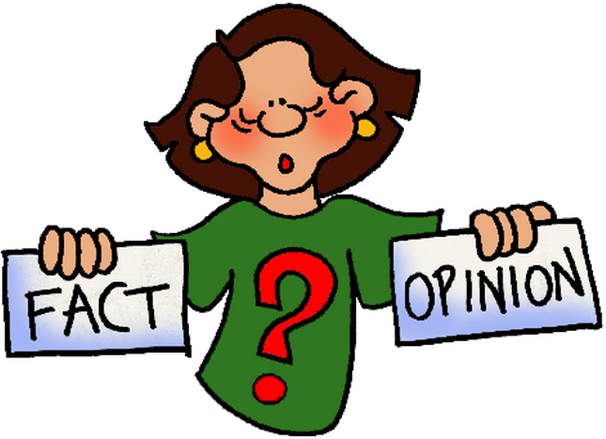 | Is That a Fact?
 | Distinguishing Between Facts and Opinions

In the spaces below, write a fact or an opinion you read or heard. Your classmates will try to determine which it is. Try to stump them! You should have a minimum of three facts and three opinions. Mix them up.

Fact | Opinion
Fact | Opinion
Fact | Opinion
Fact | Opinion
Fact | Opinion
Fact | Opinion
Fact | Opinion
Fact | Opinion

Flip-Flop: Choose three facts from your list above and write them as if they were opinions. |  | Flip-Flop: Choose three opinions from your list above and write them as if they were facts.
 |  | 1.
 |  | 2.
 |  | 3.

